This is your quasi-daily update on the 2022 ABoVE Airborne Campaign

Tuesday 12 July, 2022 (DOY 192)

Chip Miller is in Fairbanks, AK.
Peter Griffith is in Maryland.

NASA’s 2022 airborne activities are scheduled to include AVIRIS-NG hyperspectral imaging (5 July – 25 August) and the L-band polInSAR (9 August – 22 August). Flights will provide acquisitions across the ABoVE domain in Alaska and northwestern Canada in coordination with ABoVE field work

ABoVE will coordinate with the DLR CoMet 2.0 Arctic (operating from Edmonton ~12 Aug – 15 Sep), G-LiHT (6-30 July in southern/SW Alaska), and NEON AOP (operating out of Deadhorse AK 20 July – 22 Aug) teams.

More information may be found on the summary page for the ABoVE 2022 Airborne Campaign

Sensor/Aircraft Summaries and 72-hour Look Aheads

AVIRIS-NG (Dynamic Aviation B-200 N53W)
July 2: Transit Great Falls MT (GTF) – Bellingham, WA – Juneau, AK – Fairbanks, AK

July 3: Crew rest day; Clean AVIRIS window

July 4: Hard Down Day; >5000 lightning strikes forecasted for AK
Jackie Hung and a Woodwell research team are in the YK Delta

July 5: First flight day.
Excellent cloud-free conditions found in several locations, but ALL LINES had significant low level smoke interference. It was impossible to see the ground in several locations. These are likely the conditions in Alaska until the August rains begin to extinguish the large wildfires.
Cloud front was further east than forecasted, so Beaver AK area box was aborted after 1 line. Moved north along the Dalton Hwy into less cloudy areas. Acquired several lines in the Toolik Lake area before clouds moved in there. Returned to the Fairbanks area where boxes over the Goldstream Valley, Nugget fire scar, and the BNZ LTER/APEX targets were acquired

July 6: Flight day #2.
Flew Beaver, AK grid, Coldfoot and Bettles lines, Grouse Creek fire scar grid, Hess Creek fire scar line, and CPCRW/flux towers line. Less smoky conditions in the north, but still far from ideal. Visible wavelengths severely compromised.

July 7: Down Day
Resetting crew clocks in advance of extended good weather forecasts

July 8: Down Day
Replacement pilot arrival delayed due to cancelled flight

July 9: Flight day #3.
Forecast for clear skies and low smoke over eastern North Slope
Flew lines over Dalton Hwy, Anaktuvuk River fire scar, Nuiqsut, and Deadhorse areas. Attempted flights over North Slope coastal boxes, but sea ice still covered more than 50% of the lines – will need to revisit these lines towards the end of July

July 10: Flight day #4.
Forecast for clear skies and no smoke over the Kotzebue/Noatak region
Tranist – entire Interior filled with smoke south of the Brooks Range
Sortie #1: flew Noorvik and Kotzebue grids
Sortie #2: flew all Lower and Upper Noatak Valley lines and part of the Selawik grid
Outstanding conditions all day long: clear skies and no smoke
Observed scattered clouds over the Seward Peninsula with increasing high cirrus during the day. Returned to dense smoke advisory in Fairbanks
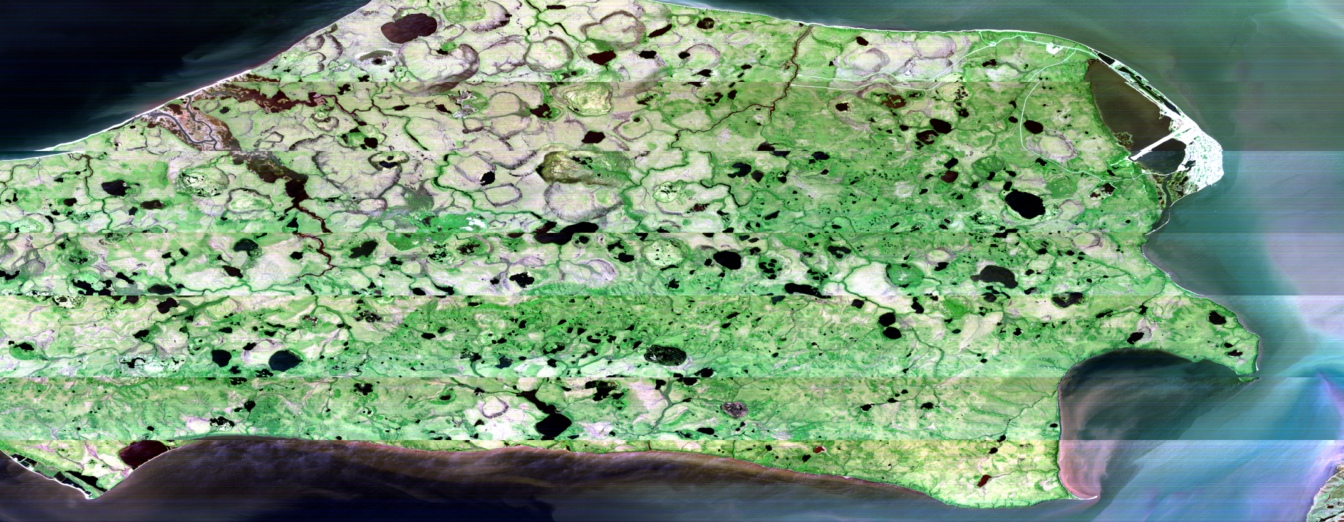
Composite image of Baldwin Peninsula (Kotzebue at Right) from 7/10/22

July 11: Down Day
Clouds moving in across Alaska, no combination of clear skies and smoke-free conditions in any priority areas, so called for a down day after 2 long flying days

July 12: Down Day (Weather).
Forecasts at 0800 showed areas clear skies over Seward Peninsula and Kotzebue, but with significant uncertainty. Forecasts for Wed 7/13 showed better conditions, so we cancelled for today and are targeting Seward Peninsula (NGEE-Arctic) sites and completion of Kotzebue area lines on Wed 7/13. Mid-day satellite imagery shows that this was a good call with cloud cover remaining across the state, even the Sew Pen/Noatak region – see satellite imagery below
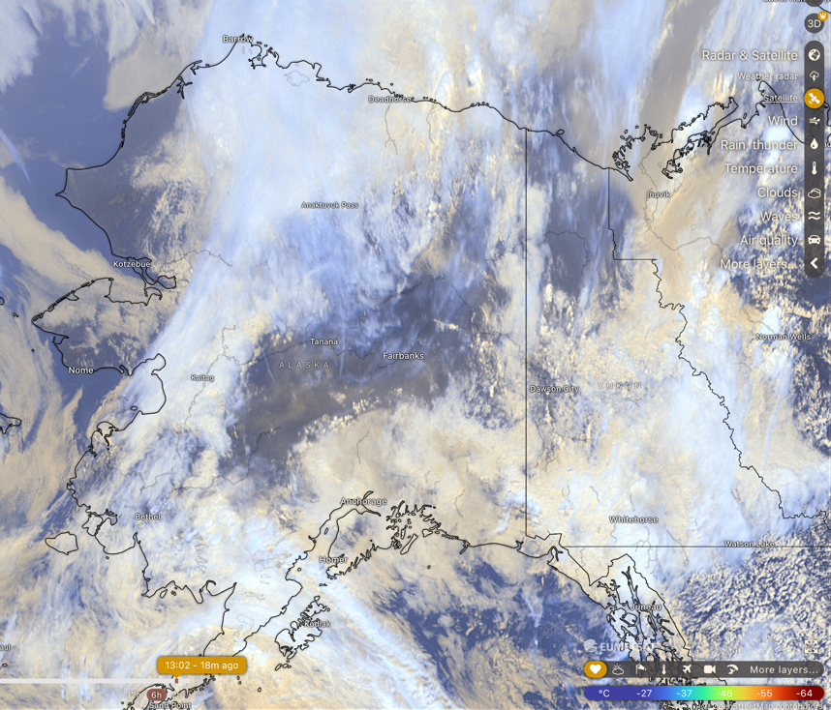

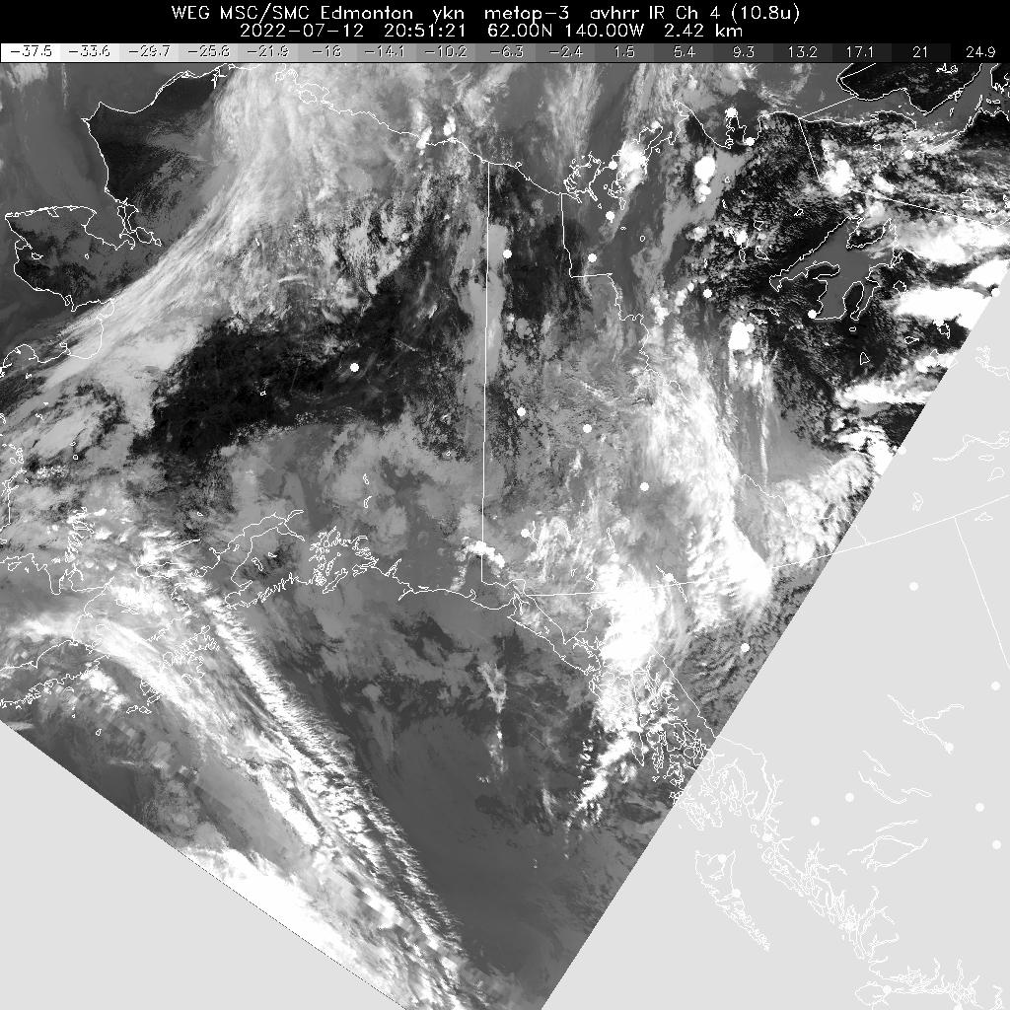

AVIRIS quicklooks: https://avng.jpl.nasa.gov/pub/ABoVE/quicklooks/.

Wes Moses (NRL) confirmed that his offshore lines between the Colville and Sag Deltas should be ice-free before being acquired. Watching conditions for that via https://www.weather.gov/afc/ice . We need to wait at least another 7-10 days before trying again based on the extent of near-shore ice encountered on 7/9/22.

Shawn Serbin and NGEE-Arctic team members arrived in Nome and are in place to support AVIRIS overflights of the Seward Peninsula sites

Kyle Kovach and Univ Wisconsin field team are collecting foliar samples through the Brooks Range and moving onto sampling North Slope sites along the Dalton Hwy

- Priority 1 = Deadhorse/Barrow Areas.
- Priority 2 = YK Delta.
- Priority 3 = Interior AK/Fairbanks Area

July 13: Potential flight day.
Forecasts showing potential for large area of clear sky conditions over NW Alaska from Atqasuk to Noatak and Seward Peninsula. Smoke forecast shows it all moving into SE Alaska below a Wiseman-Bettles-Galena-Kaltag line. Primary Target: Seward Peninsula/NGEE-Arctic sites. Secondary Target: remaining lines in the Noorvik, Selawik, and Huslia areas

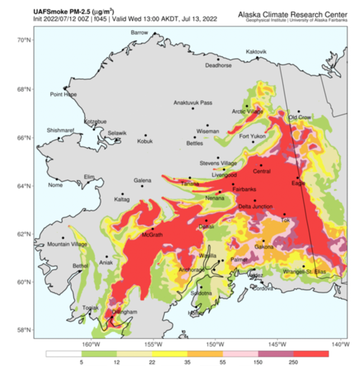

July 14: Potential flight day.
Current forecasts show pervasive clouds across Alaska. Smoke remains confined to SE AK. Potential target: King Salmon. Watch for updates

July 15: Potential flight day.
Forecasts show continuing cloud cover across Alaska. No obvious targets. Watch for updates
G-LiHT (Dynamic Aviation Beechcraft King Air N80Y)
Integration & Testing (Bridgewater, VA): 28-30 June 2022
Transit to AK: 1-6 July 2022
Base of Operation and Dates :
Kodiak, AK -- 6-16 July 2022
Aniak, AK -- 16-26 July 2022
Kodiak, AK -- 26-30 July 2022
Description of science flights and motivation

July 2: G-LiHT transits from Bridgewater VA – Perry, IA
July 3: G-LiHT transits from Perry IA – Sheridan County, WY
July 4: G-LiHT transits Sheridan County, WY – Wenatchee, WA
July 4: G-LiHT transits Sheridan County, WY – Wenatchee, WA – Juneau, AK
July 5: G-LiHT transits Juneau, AK – Kodiak AK; in position to begin operations
July 6: G-LiHT in Kodiak AK; no flights on tracker
July 9: G-LiHT in Kodiak AK; 2 sorties near King Salmon, AK
July 10: G-LiHT in Kodiak AK; 2 sorties near King Salmon, AK
July 11: G-LiHT in Kodiak AK; flying near Dillingham, AK @ 1516 AKDT
July 12: G-LiHT in Kodiak AK; no activity shown as of 1345 AKDT

NEON Airborne Observation Platform #1 (Daily Flight Reports)
July 17 – Transit through Fairbanks
July 18 – Aug 22: First candidate flight day – Toolik Lake area

L-band SAR (JSC G-III NASA2)
June - July: planned non-ABoVE CONUS flights
Aug 9: Transit Houston – Saskatoon (TBC)
Aug 10: BERMS area TomoSAR
Aug 11: Transit to Yellowknife

CoMet 2.0 Arctic (HALO G-550 D-ADLR)
Aug 6: Transit to Edmonton
Aug 10: First candidate flight day

Weather Forecast: ABoVE Domain

GEOS-FP for ABoVE: https://fluid.nccs.nasa.gov/missions/mission_ABOVE/
HRRR for Alaska: https://rapidrefresh.noaa.gov/alaska/
Windy weather visualization: https://www.windy.com/
FAA Weather Cameras – Interactive map with Alaska and Canadian cameras: https://weathercams.faa.gov/
Alaska Fires and Smoke Predictions: http://smoke.alaska.edu/current_fires.html
Sea ice extent: https://www.weather.gov/afc/ice
Solar Elevation Calculator: https://aa.usno.navy.mil/data/AltAz

Fire activity updates 7/11/22 http://smoke.alaska.edu/current_fires.html :

1300 AKDT on 7/12/22: Fairbanks AQI = 159 https://www.iqair.com/us/usa/alaska/fairbanks

Lightning strike map
https://www.arcgis.com/apps/webappviewer/index.html?id=f5c311fa930d4831916c3f27984e97fd&extent=-21498469.1666%2C7047820.6016%2C-12281998.0441%2C11636488.2836%2C102100

Last updated: 12 Jul 2022, 13:00. Data from the Alaska Interagency Coordination Center, which is currently tracking 500 fires in Alaska (active, smoldering or in the process of being demobilized).

Multiple large fires burning west of Fairbanks:
- Minto Lakes (37,523 acres, no change since 7/11/22)
- Tanana River (23,620 acres, no change since 7/11/22)
- Clear (70,593 acres, +900 acres since 7/11/22)
- Chitanana (89,000 acres, +5000 acres since 7/11/22)

Multiple large (>100,000 acre) fires burning in SW Alaska and the YK Delta contributing to smoky conditions across Interior AK. Fires of particular note:
- Douglas (20,945 acres) south of Coldfoot is burning on both sides of the Dalton Hwy and may impact travel between Fairbanks and Deadhorse
- Hog Butte (199, 436 acres) between Lake Minchumina and Nikolai
- Tatlawiksuk (226,000 acres), Aghaluk Mountain (116,000 acres), and Koktuli River/Pike Creek (205,866 acres) causing smoke over most of western and Interior AK
- East Fork (167, 000 acres) and Apoon Pass (84,000 acres), both near St Mary’s

Minto Lakes fire
Discovered: 6/21/2022 4:34:39 PM
Last updated: 7/12/2022 9:13:09 AM
37523 acres
Thunderstorms over a majority of the fire area last night and this morning provided a wetting rain. Rainfall amounts over last 24 hours (16:30-16:30 AKDT) ranged from 0.07" to 0.97" inches. These values were recorded from three RAWS stationed around the fire`s perimeter. The rain has significantly diminished fire activity, with most locations showing minimal activity overall. Although some areas have shown diminished activity, the fire is holding in exceptionally dry deep duff and heavier fuels.

Clear fire
Discovered: 6/21/2022 5:05:10 PM
Last updated: 7/12/2022 12:04:05 PM
70593 acres
Aggressive suppression activities being conducted have minimized available fuel. Thunderstorms brought some precipitation and reduced the fire behavior. Primary fire behavior throughout the entire fire area was creeping and smoldering.

Bitzshitini fire
Discovered: 6/19/2022 5:04:00 PM
Last updated: 7/10/2022 5:50:36 AM
65079 acres
Smokejumpers continue to hold and improve the mop up work around the cabins to the north and east of this fire. Point protection remains a priority on this fire.

*** Ground truth providers seeking information on timing of potential overflights should text or email Chip Miller and Peter Griffith ***

If you do not wish to receive the daily airborne briefing, you may unsubscribe at any time by sending an email to support@cce.nasa.gov with "Unsubscribe Airborne Daily” as the subject.

